Hello Parents/ Guardians,
The Alpha Achievers of Howard County are inviting you and your student(s) to their annual workshop “Middle School Boys, To Men of Purpose: A Positive Pulse on Mental Health”. This workshop was designed to educate your young male student on the high school experience and what it takes to be successful through these times. The transition from 8th grade to high school is a stressful one, and it seems like there isn’t enough open and honest conversations about what is expected. We want to provide your students an upper hand on this transition so they can conquer it with less hassle. Come on out to this workshop and see what it can do for your child!
Now, this workshop is not just for the students, but it is designed to cater to the needs of the parents as well. We understand that going to high school isn’t just a transition for students, but also for parents. And during this transition, parents don’t always get the information they need in order to make more executive decisions for their child and their education. We are here to fix that too! Not only will you have a delicious lunch, but you will have the opportunity to learn about a number of supports offered in the schools. You will also get information on stress management, student supports, and the differences between high school and middle school. you will also be provided the opportunity to meet a lot of the outside supports this county has to offer.
This is something you do not want to miss, so please RSVP at: https://boystomenofpurpose2019.eventbrite.com
by April 6th 2019. The school counselors at your child’s respective school are aware of this event, and you can reach them for more information. You can also contact Anthone Bond at Anthone_bond@hcpss.org for any questions you may have. We hope to see you there!
When: April 13th, 2019
Time: 10 am – 2 pm
Where: Long Reach High School
6101 Old Dobbin Lane Columbia, 21045
Why: To help support parents and their students through their transition into high school and address rising rate of mental health concerns in the community.

We are kicking off the event with our sessions and then serving lunch! So please come on out and take advantage of this workshop. You don’t want to miss it! Please RSVP at the above link by April 6th. We can’t wait to see you there!

Anthone Bond
Alpha Achiever Program Director
Long Reach High School
Anthone_bond@hcpss.org
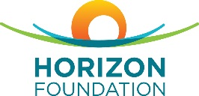
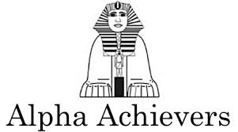
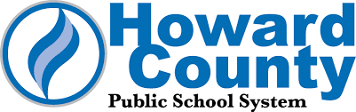
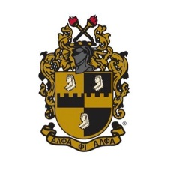
(410) 313-7117

